**MOUNT KENYA UNIVERSITY**

**SCHOOL OF COMPUTING AND INFORMATICS**

**DEPARTMENT OF IT**

**PROJECT NAME:** A LOCATION-BASED BLOOD DONATION SYSTEM

***This research is submitted school of computing and Informatics, in partial fulfilment of the degree of BSc.IT***

***Submitted By: Ali Bwanamzee Zani***

***BIT/2018/86570***

**DECLARATION**

I declare that this work as my own and has not been previously submitted and approved for the award of a degree by this or any other University.

Student Reg No:ALI BWANAMZEE ZANI BIT/2018/86570

…………………………………………………. (Signature)

**DEDICATION**

I dedicate this project to all my supportive friends who kept giving me constant advice and support throughout the entire period and made the project a success. I thank my parents for their support and assistance in ensuring that the project was complete. .

# 

# ACKNOWLEDGEMENT

This project itself is an acknowledgement to the inspiration, drive and technical assistance of many individuals. We express our gratitude to Mount Kenya University management for providing us with an enabling environment and excellent infrastructure to lay a strong foundation for our professional lives.

We extend our heartfelt gratitude to the head of faculty of Science Information and Technology and the entire department, our lecturers and friends for their support and timely help.

**Contents**

Chapter 1 7

1.0Introduction 7

1.1Background 7

1.2Problem statement 9

1.3Research objectives 10

1.3.1General objective 10

1.3.2Specific objectives 10

1.4 Research Questions 10

1.5 Significance of the study 10

1.6 Scope and limitation of the study 11

Chapter 2: Literature Review 12

2.0 Introduction 12

2.1 To investigate the blood donation process 12

2.2To analyse techniques used to source for blood donors. 13

2.3 To design and develop a location-based web application program for sourcing of blood donors 17

Chapter 3: Research Methodology 18

3.1 Research methodology/Research design used 18

3.2 Data collection methods used. 18

3.3 Design Diagrams 19

3.3.1Use case Diagram 19

3.3.2.CONTEXT DIAGRAM 20

3.3.3 DFD DIAGRAM 21

# 

# List of Abbreviations/Acronyms

GPS - Global Positioning System

IDE - Integrated Development Environment

KNBTS - Kenya National Blood Transfusion Service

KNN - K-Nearest Neighbour

RDBMS - Relation Database Management System

UNDP - United Nations Development Programme

VNRBD - Voluntary Non-Remunerated Blood Donors

WHO - World Health Organization

# Chapter 1

## 1.0Introduction

Blood supply from blood donations is essential in ensuring the survival of individuals who undergo blood transfusion. In India, mobile and web applications are used to source for voluntary non-remunerated blood donors to ensure timely and adequate supply of safe blood during emergencies while in Kenya methods used to source for voluntary non-remunerated blood donors include conducting of blood donation drives by KNBTS, blood communities like Wanadamu responding to blood appeals and social media platforms used to send appeals to willing donors when there is urgent need of blood. However, certain challenges (especially in Kenya) in relation to blood supply have arisen due to the drawbacks in the platforms used to source for blood donors in Kenya at such a time. This research aimed at developing a location-based web application program(in pursuit of solving the problem resulting from the above-mentioned challenge) that will aim towards easing the process of sourcing for blood donors and eventually contribute towards timely access to adequate supply of safe blood. The system analysis and design method that was employed during the development of the system is OOAD while the system development methodology employed is Iterative System methodology. The system testing techniques that were employed to ensure the system meets the specified requirements were functionality testing, usability testing and unit testing. The outcome of the research is a web-based application that will enable hospitals or medical centres in need of blood to be donated to patients, to send blood requests to willing donors that have been registered on the system

## 1.1Background

The blood donation process plays a crucial role in saving the lives of millions of people. That is, one pint of blood can save up to four lives (KNBTS, 2019). It is not detrimental to donate blood as the body can replenish the donated blood; plasma replaced within 24 hours and platelets, white blood cells and red blood cells replaced within 2 weeks. It is because of this, that blood donation is the best way to get blood for individuals undergoing the blood transfusion process, at a time when the quantity of blood falls short of the amount required, to ascertain proper functioning of the body. Shortage in blood supply in one’s body can be attributed to being involved in an accident such that huge amounts of blood is lost, having undergone operation that involves high loss of blood, being anaemic or having leukaemia. Therefore, it goes without saying that the blood donation process plays a crucial role not only in ensuring adequate supply of safe blood but also timely access to adequate supply of safe blood (Omboki, 2018).

The history surrounding blood transfusion in Kenya indicates that hospitals sourced for their own blood in the late 1960s. This is because the blood transfusion service was administered as part of the hospital’s lab services, without staff, specialized equipment and a dedicated budget line. In addition to that, it is said that the emergence of HIV/AIDS from 1985 resulted in the reduction of blood collected, increase in the cost of blood and prominence of blood safety becoming critical (KNBTS, 2019).

The necessity for ample and reliable blood supply, however, became evident after the bomb explosion in Nairobi in August 7, 1998 and thus contributed towards the formation of the Kenya National Blood Transfusion Service (KNBTS) in 2001, with the help of the government of the United States (KNBTS, 2019). Currently, KNBTS is responsible for the coordination and management of the national blood transfusion programme. It has also been given mandate by the ministry of health to oversee the collection and distribution of blood from blood donations carried out in Kenya. Besides that, the KNBTS is charged with the recruitment and retention of Voluntary Non-Remunerated Blood Donors (VNRBDs).

The KNBTS also consists of six centralized blood banks in Kenya known as Regional Blood Transfusion Centres (RBTC) where willing donors can voluntarily go to donate blood for individuals in dire need of it (blood recipients) and, the blood is stored until the point of demand 2 for it becomes apparent. The RBTC’s are situated in Nakuru, Embu, Nairobi, Eldoret, Mombasa and Kisumu. Moreover, it has satellite centres; blood banks which are situated in county hospitals. All these blood banks supplement the blood supply that is required for performing blood transfusion on patients in critical need of blood, in hospitals within Kenya (KNBTS, 2019).

Apart from KNBTS, Bloodlink foundation is involved in the recruitment and mobilization of blood donors to ensure adequate and safe blood for Kenyans in need of blood. It is a non-profitable charitable trust that purposes to help Kenyans realize better health and improved quality of life through partnering with public sectors, communities and organizations in the corporate world. Moreover, it engages with the public to sensitize them on the urgent need of blood in the country by carrying out health talks prior to blood donation drives to urge potential donors to donate blood. (Bloodlink foundation, 2019)

According to the KNBTS, there has been an increase in the number of units of blood collected per year up until 2015. However, the number of units of blood collected in 2017 decreased in number. This can evidently be seen in the number of units reported to be collected in the recent years as illustrated in the figure in appendix A. In addition to that, it has been revealed that 80% of blood in the national blood bank is collected from students in secondary schools and colleges within the ages of 16-25 years. This being that such institutions have many healthy youths concentrated in one place, yet youths make about the largest percentage of the Kenyan population at 75% (Omboki, 2018).

According to statistics, in every 10 mins a patient is in critical need of that lifesaving unit of blood and every day, at least 1100 patients need blood (Omboki, 2018), yet hospitals still face a weighty challenge in performing blood transfusion to patients in dire need of blood. Moreover, the maternal mortality rate, due to postpartum haemorrhage remains monstrously high at 488 maternal deaths per 100000 live births with several regions recording as high as 1000 maternal deaths per 100000 live births as (UNDP, 2019). This can be attributed to the fact that the blood banks still face a challenge of shortage in blood supply despite the amount of blood collected from Voluntary NonRemunerated Blood Donors (VNRBDs) per year as the amount of blood collected does not hit the sufficiency target of one unit of blood per 1% of the population, yet the blood has a short shelf life of 35 days and cannot be manufactures or substituted. Therefore, this becomes a serious issue because safe blood supply of the appropriate blood group is a requirement for blood transfusion to be undertaken to save lives (Ireri, 2013).

With this, adequate supply of safe blood becomes crucial in cases of shortages experienced in blood banks and ultimately affects the timely access to adequate supply of safe blood as blood supply must be sourced elsewhere by looking for VNRBDs; willing blood donors that will meet demand for blood through donation. The timely access to adequate supply of safe blood plays a chief role in guaranteeing a high probability of saving a patient’s life through blood transfusion. Thus, an opportunity arises of ensuring timely access to adequate supply of safe blood in case blood banks run out of stock, by use of information technology to come up with a way of easing the process of sourcing for VNRBDs to meet the demand for blood in such a case as mentioned above.

## 1.2Problem statement

Despite the increase in the amount of blood collection via blood donations from VNRBD such as secondary school and college students, Kenya barely scratches the surface when it comes to achieving the blood sufficiency target set by WHO, of collecting a unit of blood from 1% of the population every year (Omboki, 2018). This can be attributed to low blood donation rates as revealed by KNBTS where 70% of blood donors donate once a year while 3 in 10 people are regular donors yet, blood cannot be manufactured, has no substitute and has a short shelf life (Omboki, 2018). As a result, timely access to adequate supply of safe blood when blood banks run out of blood become a major problem faced in Kenya.

In an effort to solve this problem, hospitals, individuals and other health care centres have resorted to relying on family replacement donors or reaching out to hesitant Kenyans who might be touched to respond to their plight for blood via social media platforms such as WhatsApp and Facebook (Omboki, 2018). However, this is inadequate in solving the problem of timely access to adequate supply of safe blood being that it is seriously difficult to find a willing blood donor (VNRBD) at the right time with the latter approach as the communication is not targeted at willing blood donors.

To solve this problem, this research aims at developing a location-based web platform that will allow for tracking of blood donors and targeted communication between those in need of blood and the blood donors. This is to reduce the time spent while searching for willing blood donors.

## 1.3Research objectives

### 1.3.1General objective

The main objective of this study is to develop a location-based web platform that will be used to ease the process of sourcing for VNRBDs at a time when individuals are in dire need of blood yet there are shortages in blood supply in the blood bank.

### 1.3.2Specific objectives

i. To investigate the blood donation process

ii. To analyse techniques used to source for blood donors.

iii. To design and develop a location-based web application program for sourcing of blood donors.

## 1.4 Research Questions

i) How are voluntary non-remunerated blood donors sourced?

ii) Which techniques are used to source blood from donors?

iii) What are the possible ways of sourcing blood from blood donors?

## 1.5 Significance of the study

The significance of this study can be seen in that individuals in critical need of blood stand to benefit greatly from the outcomes of the research. That is, by developing a web application program that aims at easing the process of sourcing for VNRBDs to meet demand of blood supply when blood banks run out of blood, individuals in dire need of blood; patients will be able to receive blood in the shortest time possible and thus alleviate the risk of delayed blood transfusion which could result in the death of the patient. In entirety, this will contribute towards reduction in the mortality rate due to loss of huge amounts of blood especially that of children and mothers, who are major consumers of donated blood products.

Moreover, blood donors wishing to donate blood and using the proposed application to get to those in need of blood, stand to benefit from this research through advantages that come with donating blood. That is, they will play a major role in helping the country through the ministry of health to save lives of those in need of blood. This can be considered as a form of patriotism as one supports the country in its endeavour of ensuring good health and well-being. Moreover, thanks to the testing stage of the blood donation process one can get to know their blood group or their status and act accordingly (KNBTS, 2019).

Furthermore, the country through the ministry of health, stands to benefit from this research since by developing a platform that will ease the process of sourcing for VNRBDs to meet demand for blood in case of scarcity in blood supply in blood banks and thus reduce mortality rate, it will have made major strides in achieving the millennium development goals 4 and 5 which are reducing child mortality and improving maternal health respectively (WHO, 2019). In addition to that the country will move towards achieving the standard development goal of good health and wellbeing (UNDP, 2019).

In terms of academia, the information gathered from the outcome of the research (proposed blood donation mobile application program) such as the blood type that is mostly or least donated and the number of requests of certain blood type can be used in enriching medical research in relation to the donation of blood.

## 1.6 Scope and limitation of the study

This research purposes to focus on the blood donation process carried out in Kenya; how blood donation is carried out, what the blood donation process involves, the outcomes of the blood donation process and challenges surrounding the blood donation process. On the other hand, the developed web platform will enable for sourcing of blood donors by providing a mechanism where hospitals or medical centres can send out requests for a specific blood type (on behalf of the patients in need of blood) to willing donors (registered on their donor database) with a compatible blood type and within close proximity to the hospitals or medical centres where blood is needed.

Furthermore, the platform shall be web based for both the hospitals and medical centres sending out blood requests and the willing donors receiving and responding to the blood requests. This is because it will ease the process of maintaining of a proper communication channel between the hospitals and the voluntary non-remunerated blood donors. In addition to that, web based applications are compatible with any device or platform. Thus, the voluntary non-remunerated blood donors can access the platform even from their smart phones. This means that a great number of Kenyans can access the platform as the percentage of Kenyans that use smart phones is high at 60% as shown by (Omulo, 2017). A limitation of this research is that the focus is on online methods of communication between the hospitals or medical centres requesting for blood on behalf of their patients and the willing blood donors responding to the requests. Thus, access to the platform and its usage requires one to be within reach of internet connection.

# Chapter 2: Literature Review

# 2.0 Introduction

The purpose of this chapter is to understand the factors that are considered before blood donation is carried out in Kenya and how blood donors are sourced for by hospitals, individuals themselves or family members of such individuals. It also seeks to analyse the platforms/technologies employed when one is sourcing for blood donors to meet demand for blood when the blood banks runs out of blood supply and the challenges that arise with the usage of these platforms. From this, it aims at not only the identification of gaps but also description of the gaps in terms of what has not been done to solve the problem. Lastly, it aims at describing how the research attempted to solve the problem as identified in the previous chapter.

## 2.1 To investigate the blood donation process

**Factors that are considered before blood donation**

There are various factors that need to be considered before a VNRBD donates blood, when they donate blood and when the donated blood is transfused into the blood of that of the blood recipient. All these are essential to guarantee safety in blood transfusions. The various factors to be considered are as shown below.

**i).Blood donor eligibility**

In Kenya like most other states, an individual preparing to donate blood at the various national blood banks or blood donation drives must ensure their eligibility as donors. That is, they must meet certain requirements as stipulated by the KNBTS. They include: the individual being within the age bracket of 16 to 65 years, having a minimum weight of 50 kilograms, having a safe sexual lifestyle and the haemoglobin level should be at 12.5. Individuals who wish to donate and have not met the above-mentioned requirements, have contracted sexually transmitted diseases such as HIV and Syphilis or are drug abusers will not be eligible to donate blood (KNBTS, 2019).

**ii) Blood groups**

There are roughly thirty-six human blood group systems within three hundred and forty-six antigens as acknowledged by the International Society of Blood Transfusion. Among these, the two most important blood group systems that ascertain an individual’s blood group include: Rhesus (Rh) and ABO blood group systems (Yobos, 2019).

The ABO blood group system categorizes blood into four blood types; blood type A, B, AB and O while the Rhesus blood group system categorizes blood into two blood types: Rh+, Rh- based on whether the presence of the Rhesus antigen on surface of cells is apparent. That is, Rh+ have the Rhesus antigen present on the surface of their cells and the Rh- have the Rhesus antigen absent on the surface of their cells (Yobos, 2019).

A combination of the blood group systems categorizes blood into eight blood types; A+, B+, AB+, O+, A-, B-, AB- and O-. An individual belongs to one of the eight blood types and thus it is important that before blood transfusion is done on a patient, the blood type of the blood donor and the blood recipient is established to guarantee one’s survival after the blood transfusion process (Yobos, 2019).

**iii) Blood compatibility**

After identifying the blood group of that of the blood donor and the patient receiving the blood, both the blood groups of the donor and the recipient should be matched in order to verify compatibility as illustrated in the table below. This is vital as it gives an assurance of safe blood transfusion (Yobos, 2019).

|  |  |  |
| --- | --- | --- |
| **Blood Group** | **Can donate blood to:** | **Can receive blood from:** |
| **B+** | AB+, B+ | B-, B+, O-, O+ |
| **A+** | AB+, A+ | A-, A+, O-, O+ |
| **AB+** | AB+ | Everyone |
| **O+** | B+, AB+, O+, A+ | O-, O+ |
| **B-** | AB+, AB-, B+, B- | O-, B- |
| **A-** | A-, AB-, A+, AB+ | O-, A- |
| **AB-** | AB-, AB+ | O-, A-, B-, AB- |
| **O-** | Everyone | O- |

## 2.2To analyse techniques used to source for blood donors.

There are several ways in which Voluntary Non-Remunerated Blood Donors (VNRBDs) are sourced for in other geographical regions outside Kenya and within Kenya itself to meet the demand for adequate supply of safe blood. Below are the various techniques used while sourcing for VNRBDs in several countries.

**Blood sourcing in India**

In India, to ease the process of sourcing for VNRBDs, application programs and systems that employ various technologies such as GPS, cloud-based services and Machine Learning have been developed as a result of research. The developed application programs and systems are as shown below:

1. Android blood donor life-saving application in cloud computing

The location-based blood donor application program operates on the Android platform such that it provides a list of contact details of VNRBDs in one’s area from which, the user checks for contact details matching a related blood group and contacts them through the application, via a phone call or text message. It employs the GPS technology in the detection of user’s location and uses an algorithm that matches the user to a suitable donor, captures the available donor’s location and pushes notifications to them via their mobile phones, when blood is needed. Furthermore, it utilizes cloud-based services to permit for central and instant access to willing blood donors’ details and their location from any geographical region (T.Hilda Jenipha, 2014).

1. Android Blood bank application

Just like the above-mentioned application, this is a location-based application program that operates on the Android platform. The reason for this is that many people have smartphones thus a great number of blood donors will get attracted to the idea of donation, if an android application is used to do so. It also utilizes the GPS technology to trace the path of the user to the locations of blood banks. This enables for saving of time since the user automatically acquires the route to the desired location rather than requesting for it, manually (Prof. Snigdha, 2015).

1. Blood donation system for online users

For this system, decision tree and decision table by rules have been employed in the implementation of the matcher system; matching the blood group of that of the blood donor to that of the individual who needs blood. The matcher system applies the rules according to blood donations carried out in the blood bank situated at Myanmar, India.This provides a means for users to contact blood donors within the shortest time during emergency; when demand for blood is critical (San San Tint, 2015).

1. Blood donor application program implementation with machine learning

This application program is a location-based mobile platform and just like the above-mentioned application programs, it employs GPS to capture the location of the user and updates the location details upon completion of registration. Furthermore, it uses Geo Fire software to perform conversion of longitudes and latitudes to the names of places displayed on the Google Maps. For authentication of users via Google Firebase, it relies on cloud-based services. In addition to that, Google maps and Place API have been used so that users can see the location of people with related blood groups while they search (Diba, 2018)

However, the difference between this application and those mentioned above is apparent since it utilizes machine learning; K-Nearest Neighbour (KNN) model to classify the best-matched people. KNN is a type of supervised learning model that consists of learning algorithms which perform data analysis to analyse classifications. It is a classifier that is not only linear but also non-probabilistic since it constructs a model that allocates new examples to the different categories, when provided a training data set containing examples that are identified as belonging to one of the categories. Aside from this, the number of times a donor donates in a certain period is taken into consideration; if an individual donates more than once then they will not be eligible to donate blood as it will not be healthy to do so. Finally, filtration of donor eligibility is done according to the last time an individual donated and their age (Diba, 2018).

1. E- blood bank

This is another Android mobile application that offers emergency services to individuals in need of blood who are termed as “blood requestors”. Similarly, it allows the blood requestors to search for donors of a particular blood group on the basis of their location, view the contact list of available blood donors and push SMS alerts to the available blood donors (Shubham Pande, 2018).

**Blood sourcing in Kenya**

In Kenya, besides the blood donation drives done by the KNBTS in various parts of the country to find blood donors, there are some social platforms such as WhatsApp are used to source for voluntary non-remunerated blood donors (VNRBDs) to meet demand for blood in case the national blood banks run out of blood. Another means of sourcing for willing blood donors include use of short message applications like “Text for life” implemented by Bloodlink foundation. In addition to that, blood appeal communities like KunaVijana have launched projects like Wanadamu to respond to the dire need of blood.

1. Blood donation drives

The KNBTS usually source for VNRBDs through blood donation campaigns held in various institutions in the country such as schools, universities, churches and many more. Normally, the blood donation campaigns are held with the aim of replenishing the blood supply in blood banks through people donating their blood voluntarily. Besides that, they encourage new individuals to join the movement as new blood donors and encourage existing blood donors to continue with the spirit of donating blood during the campaigns (KNBTS, 2019).

“Show Your Love” blood donation campaign is an example of such campaigns, which was carried out by KNBTS with the support of Pledge25, on the 14th of February this year, a day that is recognized internationally as a day of love. It was carried out in 23 locations in correspondence to the existing blood donation facilities of the KNBTS such as Nairobi, Kisumu, Mombasa and Nakuru among others where several individuals showed up to donate blood in the various locations as shown in figure 2.1 below. Through this blood donation campaign, the number of units of blood collected countrywide were 2602 with Nairobi recording the highest number of units of blood ever collected in a location in a day with over 600 units (Pledge25, 2019).

One of the challenges that arises with this method of sourcing for VNRBDs to meet demand, is the uncertainty of large crowds of people showing up to donate blood. As a result, the national blood bank still experiences the problem of shortage in blood supply despite the blood donated during these campaigns. Eventually, timely access to adequate blood supply is affected and remains a problem in Kenya (Omboki, 2018)

uate blood supply is affected and remains a problem in Kenya (Omboki, 2018)

ii) Social media platforms

This method of sourcing for VNRBDs is mostly used when blood supply of a certain blood group runs out of stock in the blood banks within the proximity of the hospital at a time when a lifesaving unit of blood is critically needed to save the life of a patient. An example of a social media platform that is commonly used is WhatsApp, where notifications of need for blood are propagated from one WhatsApp group to another and from one’s WhatsApp status to another as shown in figure 2.2 below. This is done in effort to reach out to Kenyans who will be touched to voluntarily donate (Ooko, 2018).

Through this method, various Kenyans have contributed towards the saving of lives of other individuals who were in dire need of blood by donating that lifesaving unit of blood. This is evidently seen after the attack and four-day siege that transpired at the Westgate shopping mall in 2013 (Okwembah, 2013).

Through the initiatives of the government and the humanitarian agencies, Kenyans were mobilised via social platforms like WhatsApp to show up in large numbers and donate blood to the accident victims. This has been illustrated in the figure in the appendix showing the great number of Kenyans who turned up to donate blood at the Kenyatta National Hospital (KNH). In addition to that, the hospital’s head of communications revealed that over 2000 units of blood was collected from the donation drive (Daily Nation, 2013).

However, certain challenges that have arisen from this is that, the lack of direct communication between willing blood donors and patient’s in need of blood has resulted in a lot of time being taken to find a willing donor which results in delayed blood transfusions that are to be performed on patients in critical need of blood.

1. Blood communities – Wanadamu

The Wanadamu project was launched by KunaVijana(a youth initiative registered as a non-governmental organization) in 2011 for the sole purpose of bridging the gap between the blood donors and those in need of blood. It seeks to fulfill this purpose by maintaining an online database of willing blood donors who can be called upon to donate blood in the event there is dire need for blood.

The project involves responding to blood appeals sent to them by individuals via social media platforms like Facebook and Twitter or contact forms on their website.

In the process of responding to the sent blood appeals, various steps are undertaken

In addition to that, donors are contacted on a need basis via calls, Facebook or Twitter , and directed to hospitals to donate blood for a specific patient in need of blood. The only patient information shared with the blood donors is the patient’s name so that they can confirm to the laboratory who they are donating to.

Since the launch of the Wanadamu project, it has grown to having over 20000 individuals from various parts of the country registered as donors on the online database and successfully responded to over 1800 appeals from 90 different hospitals across the country

The advantages arising from the project include the ability to track the status of a blood appeal via their website and enabling people to respond to the unpredictable need for blood in time. However, challenges such as uncertainty of a good number of donors showing up to donate blood still arises.

## 2.3 To design and develop a location-based web application program for sourcing of blood donors

A mobile application will be developed and will be able to:

i) Indicate the type of blood available in the blood banks in various locations countrywide.

ii) Indicate the locations where blood is needed urgently and the type of blood that is needed.

iii) Indicate the blood donation programmes, their locations and their respective dates.

iv)Notify people to donate blood when a particular type of blood is running out of stock in the available blood banks available countrywide.

# Chapter 3: Research Methodology

The aim of this chapter is to describe the software development methodology that will be employed to achieve the set objectives in chapter one and eventually achieve the aim of the research as also mentioned in chapter one above. The justifications for choice of the software methodology shall be provided. In addition to that, the development tools that shall be exploited to develop the location-based blood donation mobile application shall be mentioned in this chapter with justification for their choice

## 3.1 Research methodology/Research design used

This research proposes to use the iterative software development methodology during the development of the location-based blood donation mobile application. This type of software development methodology has been designed to begin with minimum requirements specifications and implementation of a part of the software. After this, is the reviewing of the prototype for further requirements specifications. It involves iterations when new versions of the applications are developed.

The reason for the choice of this type of software methodology is that it is suitable when requirements of the system can be determined and comprehended, requirements of high priority can be developed first, and workings of the system can be improved throughout the progression of the development process. Furthermore, a new technology to be employed in the development of the system can be understood, then an increment can be implemented in the model/system accordingly. There are various benefits arising from the usage of the iterative software development methodology such as simplicity in system testing and performing system repairs and speedy initial delivery of the product

## 3.2 Data collection methods used.

The method used to gather system requirements is quantitative in nature. That is, questionnaires were presented to a sample of the target population and the results were analysed to understand the user’s requirements in relation to the use of a location-based blood donation system in the case of emergencies.

However, a qualitative method of gathering system requirements was also used. That is, some individuals within the target population were interviewed to analyse the efficiency of current methods used to source for blood in case of emergencies. Moreover, the system requirements were also gathered by analysing the existing blood donation systems

The requirements include: Ease of locating voluntary blood donors, communication methods/channels to donors in case of an emergency, Information security of existing systems and the number of respondents interested in a blood donation system that allows hospitals and even blood banks to track registered voluntary blood donors

## 3.3 Design Diagrams

### 3.3.1Use case Diagram

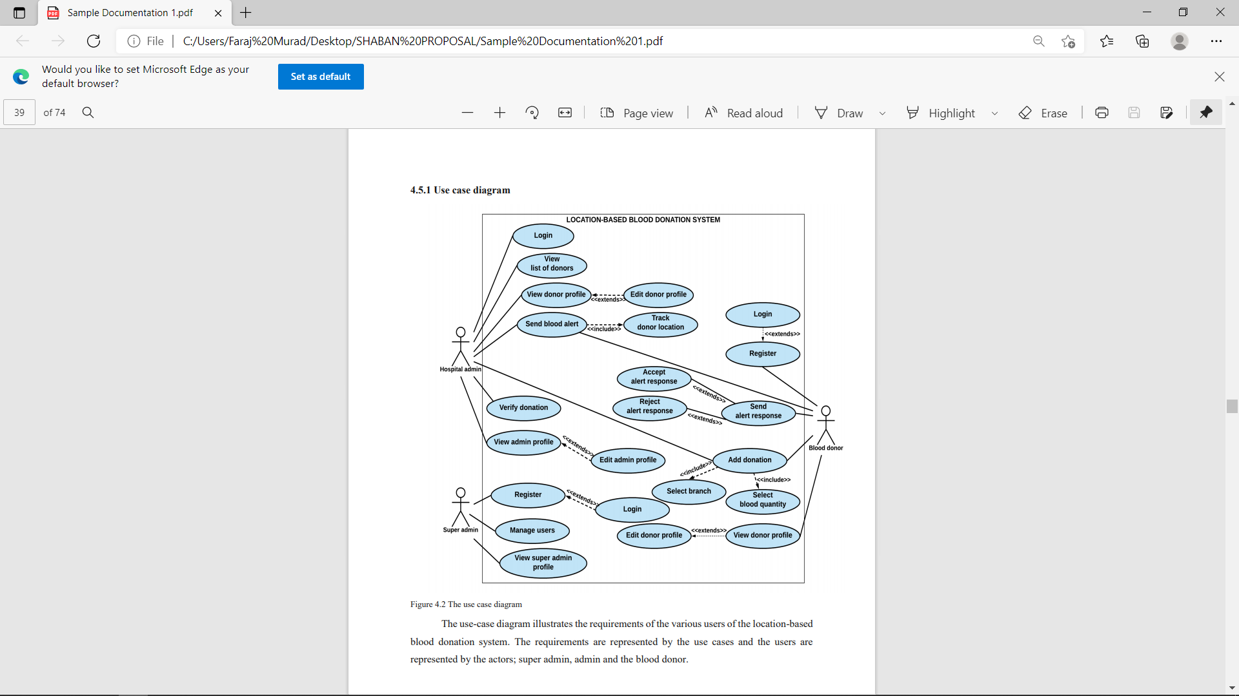

### 3.3.2.CONTEXT DIAGRAM

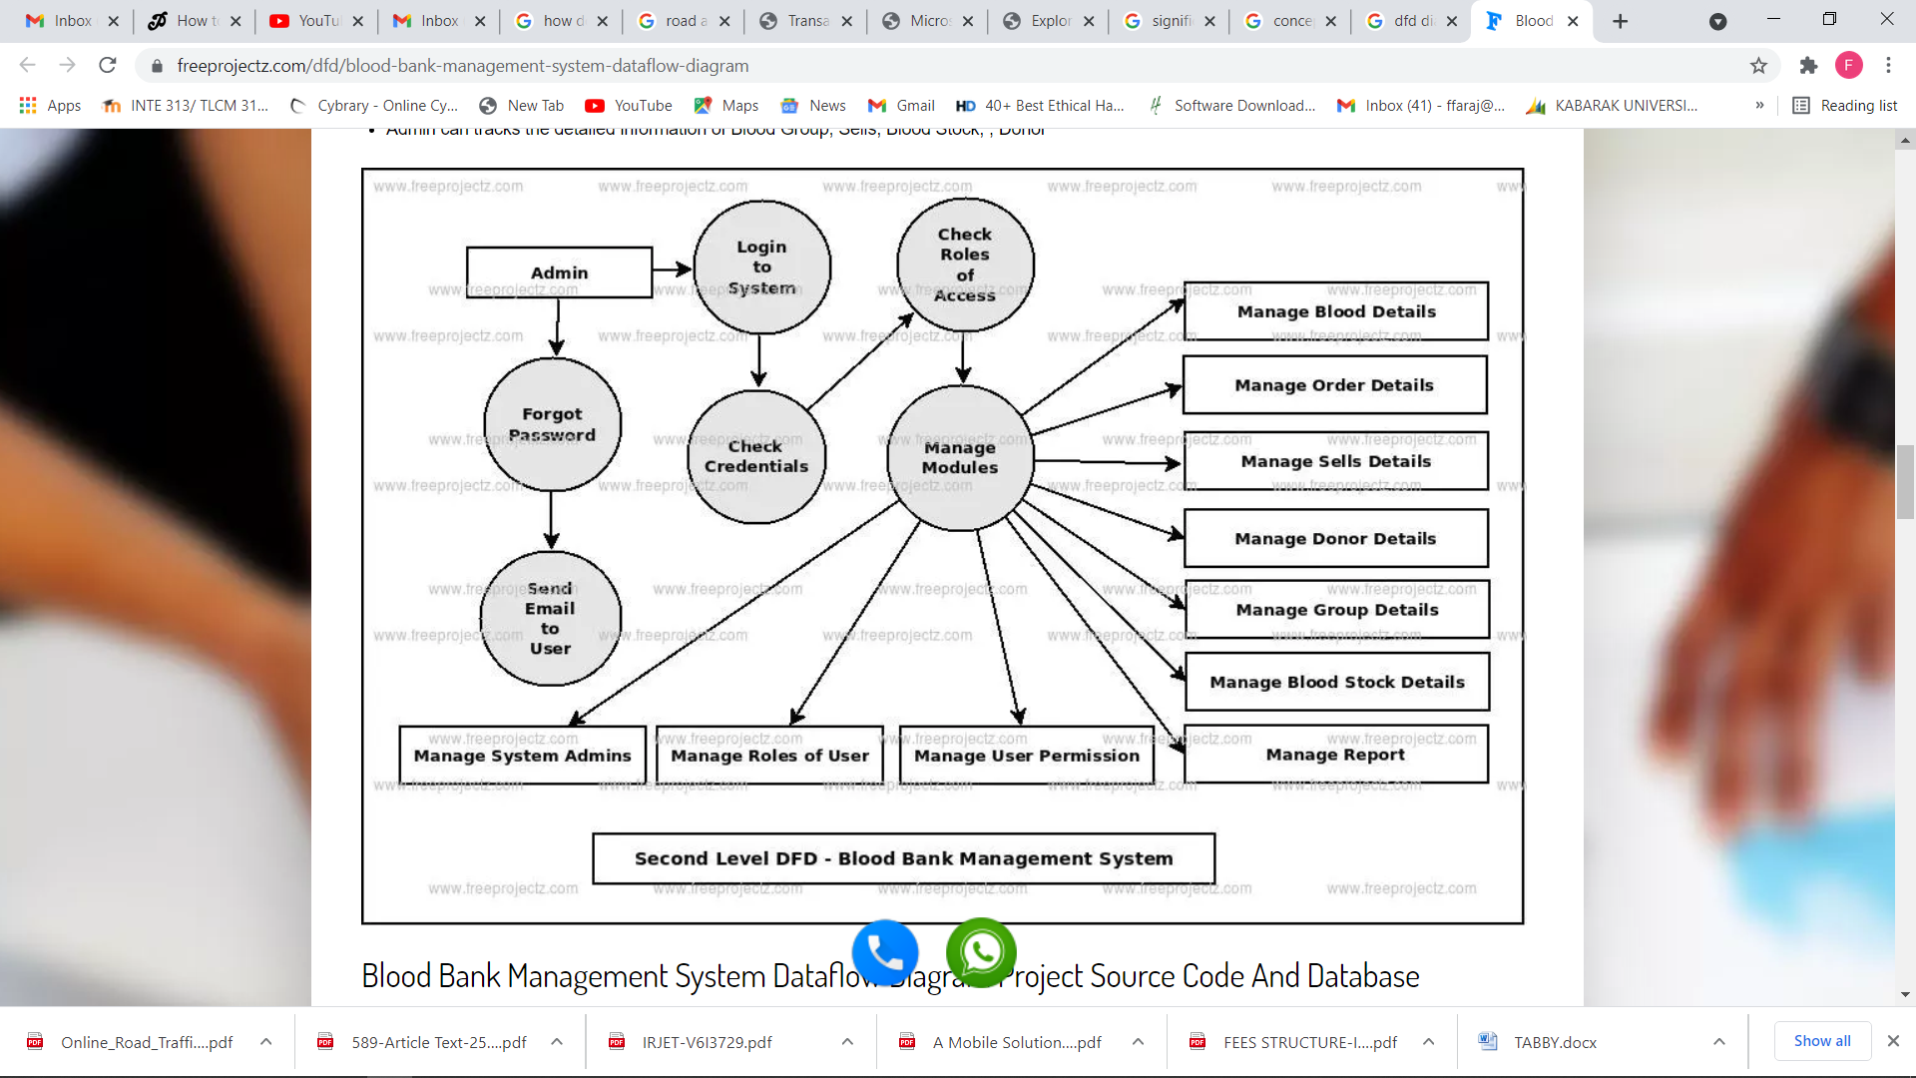

### 3.3.3 DFD DIAGRAM

